**Assignment 6**

Q1. What are events in Google analytics?

An event in Google Analytics is a way to measure a specific interaction or occurrence on a website or app.

Q2. Connect your created website and blog to search console, analytics, and google tag manager and add your faculty as a user with required permission in it.

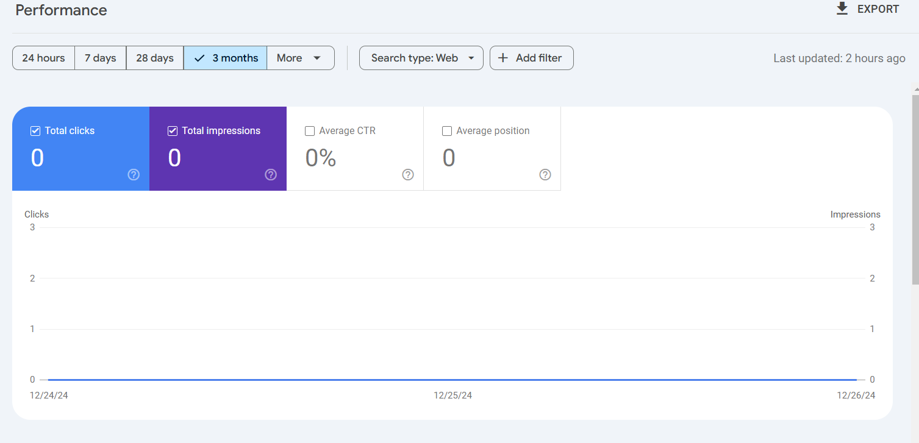

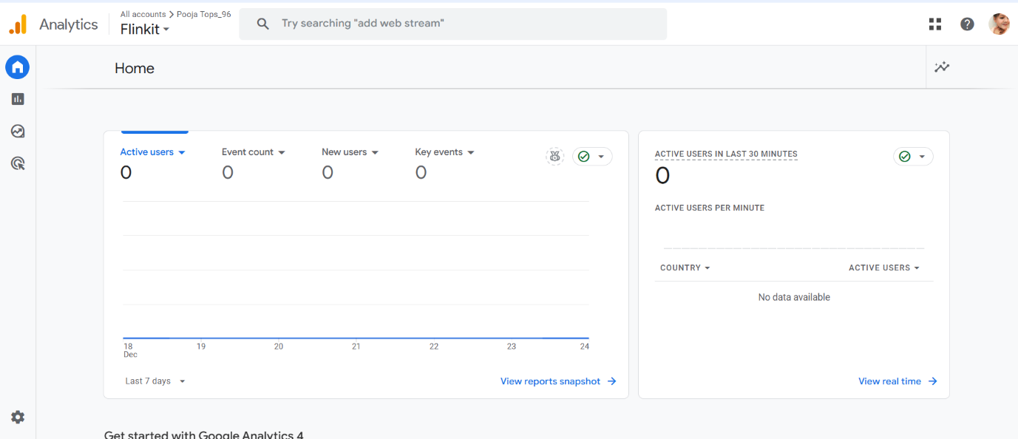

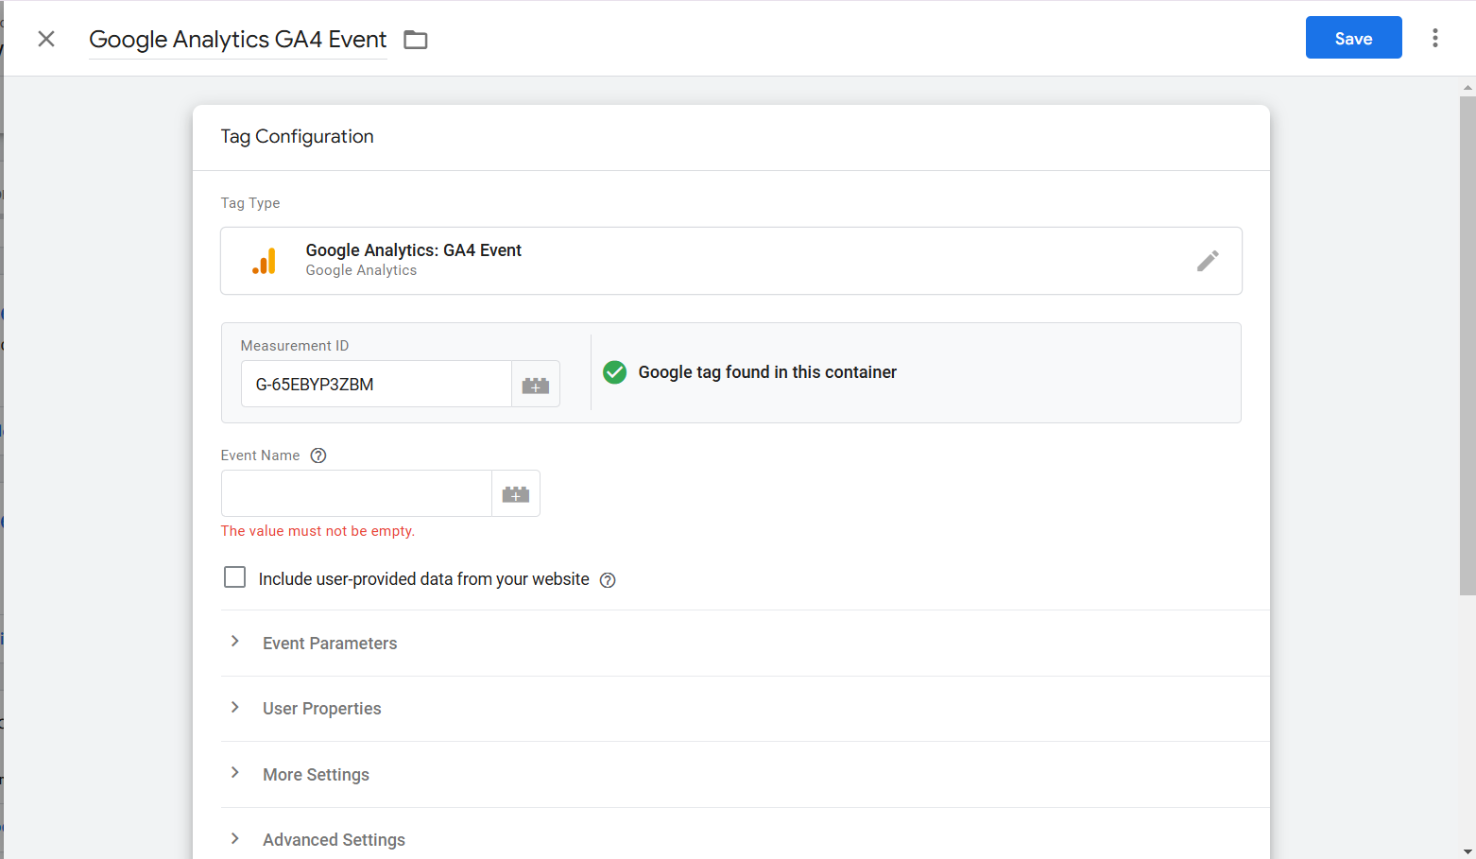 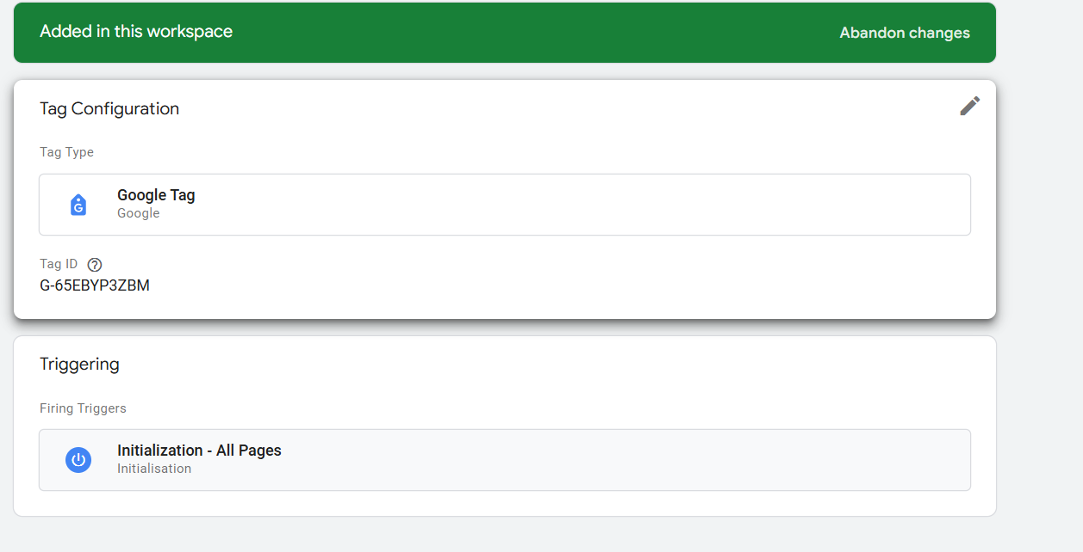

Q3. Submit the sitemap and robot.txt file in the search console for your website.

Robot.txt file :

A robot.txt file is used to instruct web crawlers (such as Googlebot) on how to interact with a website.

User-agent:*

Disallow : /admin/

We have to add this file in the root directory of our website

Eg : www.finnkit.com/robots.txt

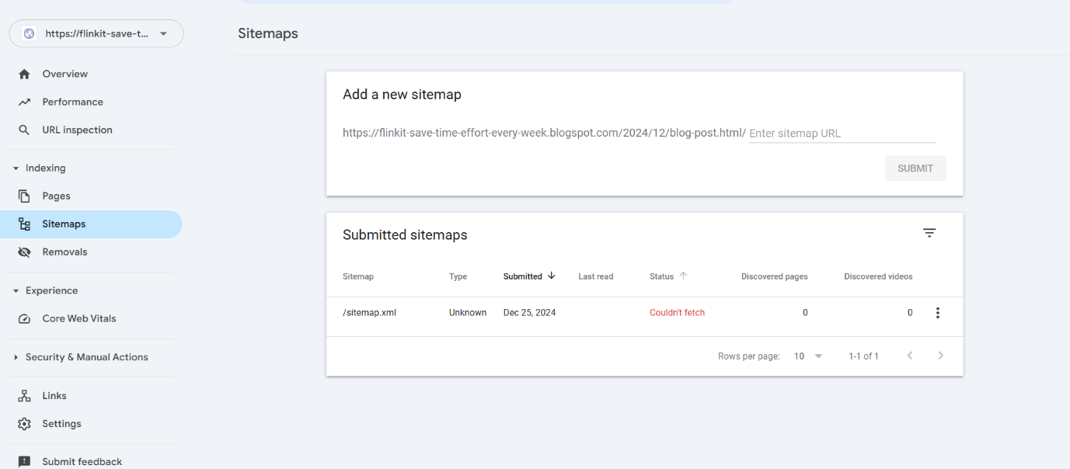

Q4. Submit the user flow and traffic source reports for your website

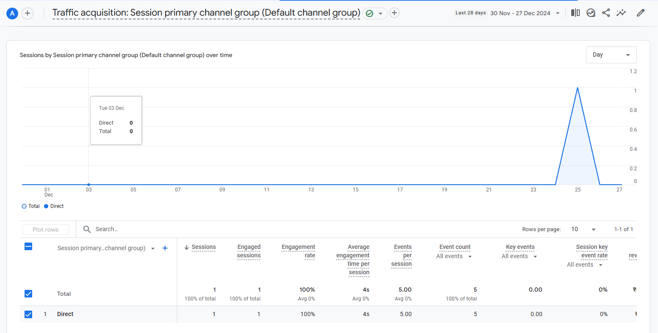

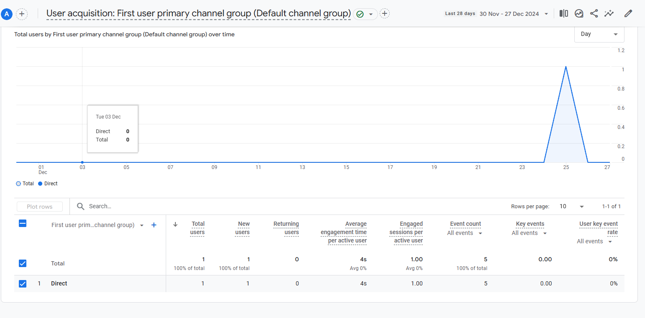

Q5. Difference between GA4 and Universal Analytics.

|  |  |  |  |
| --- | --- | --- | --- |
| **Sr. No** |  | **Universal Analytics** | **GA4** |
|  | Data Collection Model | * Based on a **session-based** tracking model. * Relies on **pageviews, events, and hits** as primary metrics. * Focuses heavily on desktop-oriented web analytics. | * Uses an **event-based** data model where every interaction (pageview, click, purchase, etc.) is treated as an event. * Provides more flexibility for tracking **cross-platform interactions** (web, app, and other digital platforms). |
|  | Cross-Platform Tracking | * Limited ability to track user interactions across multiple platforms. * Primarily designed for websites. | * Designed for **cross-platform tracking**, unifying data from apps and websites in one property. * Enables better analysis of customer journeys across devices. |
|  | Reporting Interface | * Provides predefined reports with detailed data tables. * Customization is limited compared to GA4. | * Offers **customizable reports** and focuses on **exploratory data analysis** (e.g., funnel analysis, pathing). * Simplified reporting dashboard but requires more configuration for detailed insights. |
|  | Privacy and Compliance | * Offers limited controls for user data privacy. * Requires more manual adjustments to meet modern privacy regulations like GDPR | * Built with **privacy-first principles**, including better data anonymization and flexibility in handling user data. * Doesn’t log IP addresses by default. |
|  | Machine Learning and Insights | * Basic machine learning capabilities, mostly through pre-set metrics and dimensions. | * Extensive use of **machine learning** to provide predictive insights (e.g., purchase probability). * Helps identify trends and anomalies automatically. |
|  | Event Tracking | * Requires manual tagging or configuration (e.g., setting up custom events via Google Tag Manager). * Limited to 3 event parameters: category, action, and label. | * Automatically tracks certain events (e.g., scrolling, video engagement). * Allows up to 25 custom parameters per event. |
|  | Goals vs. Conversions | * Uses static **goals**, which are limited to 20 per property. | * Focuses on **conversions**, which are more flexible and can be modified without disrupting historical data. |
|  | Data Retention | * Offers longer default retention periods (up to 50 months). | * Data retention is shorter by default (2 or 14 months), but aggregated data is still available for analysis. |

* Link Clicks: The number of times users click on a hyperlink on a webpage, email, or ad. This metric helps measure engagement and navigation patterns.
* Page Load: The time it takes for a webpage to fully load and become usable for a visitor. It’s a crucial performance metric for user experience and SEO.
* Time (How long a visitor stayed on a particular page): Also known as "time on page," this metric tracks the duration a visitor spends on a specific webpage, indicating engagement level.
* Button Click: The number of times a visitor clicks on a specific button (e.g., "Buy Now," "Submit," or "Sign Up"), reflecting conversions or desired actions.

Q6. Create a goal for your business and study reports whether it has been completed or not.

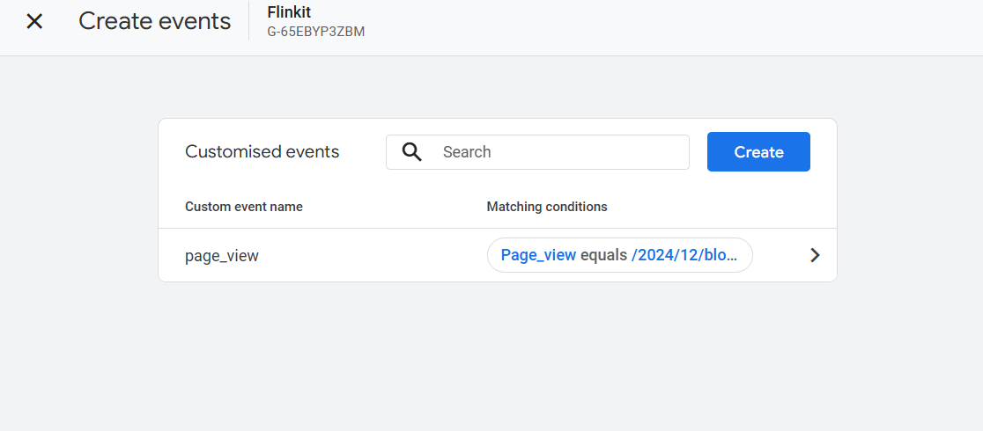

Q7.